SONARQUBE SETUP & EXECUTION

- Sonarqube is running on its latest version 9.9 in containerized form on a sparate EC2 instance/serverat port 9000 (Instance name – Jenkins slave + sonarqube).
- Pull the Sonarqube:latest image directly from docker-hub and run the same using below command:
sudo docker run -itdp 9000:9000 sonarqube:latest
- Login & password :
L – admin
P – admin123
- Created a new project – derivaz_frontend
- Created the sonar-project.properties file and added this below data in it:
sonar.host.url=http://13.233.156.150:9000 //IP address is of Jenkins slave + sonarqube instance
sonar.login=admin
sonar.password=admin123
sonar.projectKey=derivaz_frontend
sonar.projectName=derivaz_frontend
sonar.projectVersion=1.0
sonar.sourceEncoding=UTF-8
sonar.sources=src
sonar.exclusions=**/node_modules/**
sonar.tests=src
sonar.test.inclusions=**/*.spec.ts
sonar.typescript.lcov.reportPaths=coverage/lcov.info
- Update/add this below line in the script section of package.json file (package.json file of DRI Frontend repo -> development branch)
"sonar": "sonar-scanner"

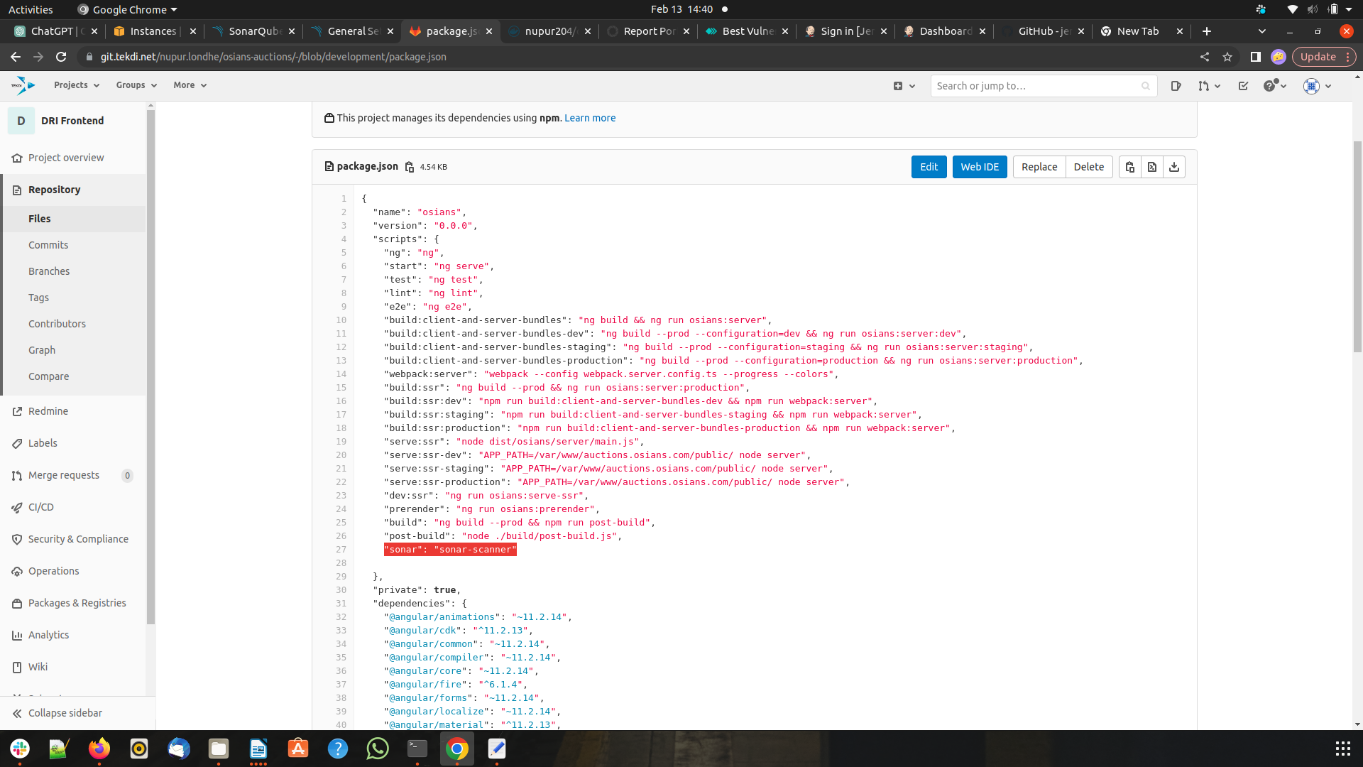

- In Jenkins pipeline sonarqube stage, added these below commands:
sudo npm install sonar-scanner –save-dev
sudo npm run sonar
- After the scan stage is successful, it will show the scan report under your project name on Sonarqube server.
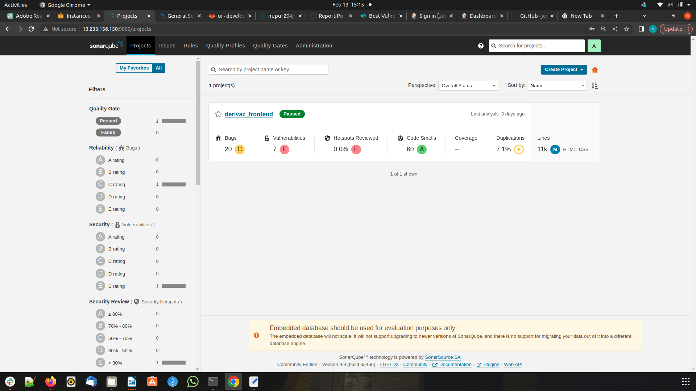

Process referenced from :
https://www.9mood.com/setup-sonarqube-with-angular-project-in-5-minutes/

